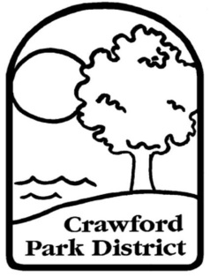
Crawford Park District
2401 SR 598 Crestline, Ohio 44827
Phone: 419-683-9000 Fax: 419-683-6281
www.crawfordparkdistrict.org
Director: Joshua Dyer
Education for Today…
Preservation for Tomorrow

Junior Naturalist Club Application
Must be 12-18 years of age

NAME ______________________________

BIRTHDAY______________

ADDRESS_________________________________________________________________________

PARENT PHONE_______________

APPLICANT PHONE (OPTIONAL)________________

PARENT EMAIL_________________________

APPLICANT EMAIL (OPTIONAL)_______________________

EMERGENCY CONTACT______________________

PHONE______________________

ALLERGIES OR MEDICAL CONDITIONS______________________________________________________________________________________________________________
(TURN PAGE)
INTERESTS_______________________________________________________________________________________________________________________________________________________

WHAT DO YOU HOPE TO EXPERIENCE AS A JUNIOR NATURALIST? (activities, things you’d like to learn, etc..)

________________________________________________________________________________________________________________________________________________________________________________________________________________________________________________

APPLICANT’S SCHOOL DISTRICT______________

PARENT/GUARDIAN SIGNATURE

__________________________ DATE_______
(SIGN)
__________________________
(PRINT)

APPLICANT SIGNATURE

_____________________________ DATE______
(SIGN)

_________________________________
(PRINT)

