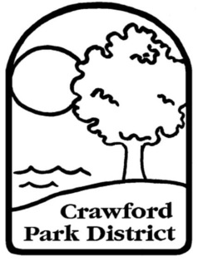
Crawford Park District
2401 SR 598 Crestline, Ohio 44827
Phone: 419-683-9000 Fax: 419-683-6281
www.crawfordparkdistrict.org
Director: Joshua Dyer
Education for Today…
Preservation for Tomorrow

VOLUNTEER ENROLLMENT FORM
(PLEASE PRINT CLEARLY)

DATE: ________________________________
NAME: _________________________________________________________________________________
PHONE: ________________________________________________________________________________
ADDRESS: _____________________________________________________________________________
CITY: _____________________________________________ZIP: _________________________________
E-MAIL: ________________________________________________________________________________
INTERESTS (CHECK ALL THAT APPLY)

____ASSEMBLING QTLY. NEWSLETTERS ____TRAIL MAINTENANCE
____NATURE CENTER VOLUNTEER ____INVASIVE PLANT REMOVAL
____SPECIAL EVENTS ____MOWING
____PARKING VEHICLES ____NATIVE SEED COLLECTION
____FACE PAINTING ____BIRD BOX MONITORING

INDIVIDUAL TALENTS: ______________________________________________________________ __________________________________________________________________________________________

REQUIRED IF UNDER 18 YEARS OF AGE:
I certify that my son/daughter is fully capable of participating as a volunteer and has my permission to participate as a volunteer for the Crawford Park District.

_________________________________________________________________________________________________________
(Signature of parent or guardian) (Minor’s date of birth)

(Signature of applicant) (today’s date)

